**Address:**

To: Dr. Christopher Peters and Mr. David Cinciruk

From: Philip Mak and Sancheet Hoque

Date: 5/24/2019

Re: Lab 5

**Introduction**

The purpose of lab 5 was implement cruise control to the electric car model system. Cruise control is a function that keeps the wheel spinning at a given rpm no matter what load is applied to the system. The loads that were used to test the cruise control feature was change in voltage throughout the system and changing a 10k potentiometer that is connected to the 0 to 5V DC value. All of the code implementation was done in the master arduino since it controls the h-bridge.

**Method/Analysis**

The cruise control implementation main focus was controlling the duty cycle of the PWM output which originally had the linear relationship with the 0 to 5V DC value. In the code, there is a 0 or 1 value to turn on cruise control; a variable “cruising rpm” was added. When the cruise control is on, the master arduino reads the rpm of the wheel and the variable rpm. The difference is calculated and then divided by 2. This is the value to add or subtract from the duty cycle depending on whether or not the rpm is higher or lower than the set cruising rpm.

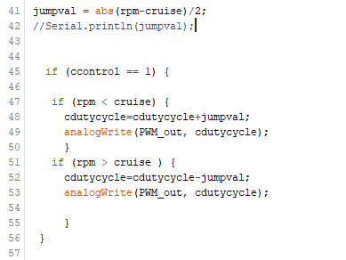

Figure I: Cruise control code

**Discussion and Conclusion**

At first, the cruise control implementation was done by using ratios of the current rpm of the wheel/max rpm produced by the wheel and cruise rpm/max rpm produced by the wheel. These values were subtracted by each other and multiplied by the maximum duty cycle outputted by the PWM (255). The issue with this was that during the voltage drop or increase test, the maximum rpm changed with the voltage change which messes up the ratios. This resulted in the incorrect rpm values. Thus, students adopted a binary adaptive method rather than a hard coded calculation.